WEEK NUMBER: | 7
STUDENT NAME: | Anas Al Azad
STUDENT ID: | [YOUR STUDENT ID]
Week 7 – TensorFlow & PyTorch, Neural Network fundamentals, MNIST digit recogniser
My checklist for this week – ticked = done (notebooks, plots and scripts are in the Lab 7 folder of my repo), unticked = still on my to-do list.
LAB 7 CHECKLIST (☒ = done, ☐ = still to do) |  | STATUS
☒ | Read the Week 7 tutorial (DL frameworks + neural network fundamentals) | Done
☒ | Installed TensorFlow 2.21 + PyTorch 2.14 and checked both work (screenshot_demo_install_check.py) | Done
☒ | NN fundamentals in numpy: activation functions + one neuron trained with backprop (nn_experiments.ipynb part A) | Done
☒ | Ran neural_net.ipynb – fixed the Keras 3 InputLayer error – 93.8% test accuracy | Done
☒ | 8 hyperparameter experiments (neurons, activation, optimiser, learning rate, batch size, epochs) – best 97.25% | Done
☒ | Confusion matrix + looked at the digits the network gets wrong | Done
☒ | Same network in PyTorch (nn_pytorch.ipynb) – 97.6% | Done
☐ | Install TensorFlow + PyTorch on my own laptop (pytorch.org selector) and run the install check | To do
☐ | Run neural_net.ipynb myself (Colab or laptop) and take the screenshots | To do
☐ | Watch the 3Blue1Brown neural network video linked in the sheet | To do
☐ | Add my screenshots (yellow boxes below) | To do
Progress: 7/11 items done

WEEK # | 7
Dates covered: | 24-30 September 2026
Lab tasks | What I did | TIME SPENT | Learning & Problems
DL frameworks: TensorFlow + PyTorch  Lab sheet section 1 | - Read about both: TensorFlow (Google Brain, 2015) and PyTorch (Facebook AI Research, 2017).  - Installed TensorFlow 2.21 (comes with Keras 3.15) with pip install tensorflow, and PyTorch 2.14 with pip, then checked pip list + imported both.  - Wrote screenshot_demo_install_check.py – prints both versions, whether a GPU is found and does a tiny matrix multiply in each library.  - Still to do: same install on my own laptop using the pytorch.org selector (screenshots 7.1–7.3). | 1 h | Learning:  - Colab has both preinstalled; locally it's pip.  - The PyTorch install command depends on OS + compute platform (CPU vs a CUDA version) – CUDA builds let you train on an NVIDIA GPU.  Problems:  - The CPU-only PyTorch download server (download.pytorch.org) was blocked on the cloud machine I first used, so I installed the normal PyPI wheel – which is the CUDA build and pulled in a few GB of NVIDIA libraries even though there's no GPU.
Neural network fundamentals  Lab sheet section 2, nn_experiments.ipynb part A | - Went through layers, neurons, weights & bias, z = Σ(w·x) + b, activation functions, loss functions (MSE, MAE, binary/categorical cross-entropy), backprop and gradient descent.  - Plotted sigmoid / tanh / ReLU and tried softmax on [2, 1, 0.1] → [0.659, 0.242, 0.099] (Fig 7.1).  - Trained one neuron by hand in numpy on the AND gate: forward pass → binary cross-entropy → backprop → gradient descent. Loss 0.694 → 0.0087, weights [8.82, 8.82], bias −13.4, predicts [0, 0, 0, 1] ✔. | 1.5 h | Learning:  - Without a non-linear activation the whole network is just one linear function.  - Sigmoid/tanh go flat at the ends (tiny gradients) → ReLU for hidden layers, softmax for the multi-class output.  - For sigmoid + cross-entropy the backprop gradient simplifies to (a − y).  Problems:  - None really for this one.
MNIST neural network  neural_net.ipynb | - MNIST: 60,000 train / 10,000 test images, 28×28, pixels 0–255 → scaled to 0–1 and flattened to 784.  - Network 784 → 32 → 64 → 10 (ReLU, softmax), SGD + sparse_categorical_crossentropy, 5 epochs: train acc 93.8%, test acc 93.80%, test loss 0.2045 (tutor's run: 93.87%).  - Prediction for x_test[45]: 5 with 93.8% probability (correct).  - Added tf.keras.utils.set_random_seed(42) so my results are reproducible. | 1 h | Learning:  - sparse_categorical_crossentropy = integer labels, categorical_crossentropy = one-hot labels.  - Scaling inputs to 0–1 helps gradient descent converge.  - The output is 10 probabilities – np.argmax picks the digit.  Problems:  - The provided code crashes on current TensorFlow (Keras 3): InputLayer(input_shape=28*28) → *ValueError: Cannot convert '784' to a shape*. Fixed with InputLayer(shape=(28*28,)) (input_shape is deprecated and it has to be a tuple). Fixed the same line in neural_net.py.  - The comments say 64 / 128 units but the code actually uses 32 / 64.
Extra – hyperparameter experiments  nn_experiments.ipynb parts B–C | - The notebook says to try combinations, so I ran 8 configs (same seed, 10% of the training set held out for validation) (Fig 7.2, 7.3):  - Adam 96.8% vs SGD 93.8% with the same network; SGD with lr = 0.1 → 96.5%; sigmoid instead of ReLU → only 76.6%; batch size 256 → 87.8%; best = Adam, 256-128, 10 epochs → 97.25%.  - Confusion matrix of the best model: most mix-ups are 2→3, 4→9, 7→3, 9→8; plotted some wrong digits – mostly messy ones (Fig 7.4, 7.5). | 2 h | Learning:  - Optimiser / learning rate made the biggest difference, then size + epochs.  - Bigger batch = fewer weight updates per epoch, so it needs more epochs.  - The biggest model's validation loss starts going back up around epoch 9–10 while training loss keeps falling → overfitting.  Problems:  - Every run takes 15–60 s on CPU (no GPU), so I kept it to 8 experiments instead of a full grid search.
Extra – PyTorch version  nn_pytorch.ipynb | - Rebuilt the network (784 → 128 → 64 → 10) in PyTorch with my own training loop: zero_grad → forward → loss → backward → step.  - Adam, 5 epochs: 97.6% test accuracy in 18 s on CPU – about the same as Keras. | 1 h | Learning:  - Keras hides the loop in fit(), PyTorch makes you write it – more code but you see every step from the lab sheet.  - nn.CrossEntropyLoss already includes the softmax, so no softmax layer at the end.  Problems:  - Running TensorFlow training and PyTorch training in the same Jupyter kernel crashed it (segfault – the two libraries clash). Moved PyTorch into its own notebook and loaded MNIST straight from the .npz file with numpy so it doesn't need TensorFlow.
TOTAL TIME THIS WEEK |  | 6.5 h | + ~45 min laptop install & screenshots

Screenshots:
Figures 7.1–7.6 come straight out of my nn_experiments.ipynb. The yellow boxes are screenshots I still need to grab from my laptop.
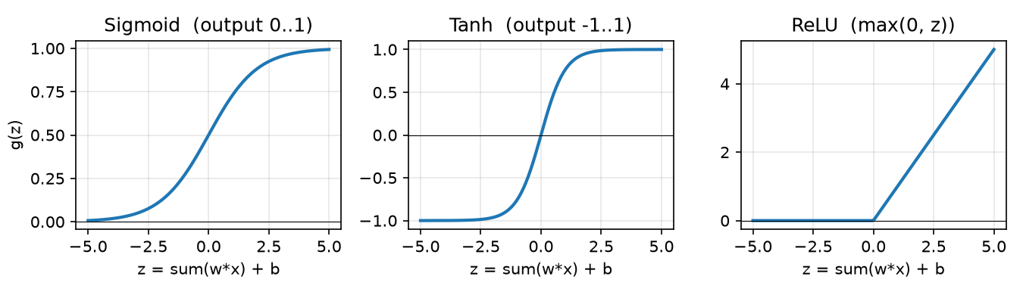
Figure 7.1 – the activation functions from the lab sheet
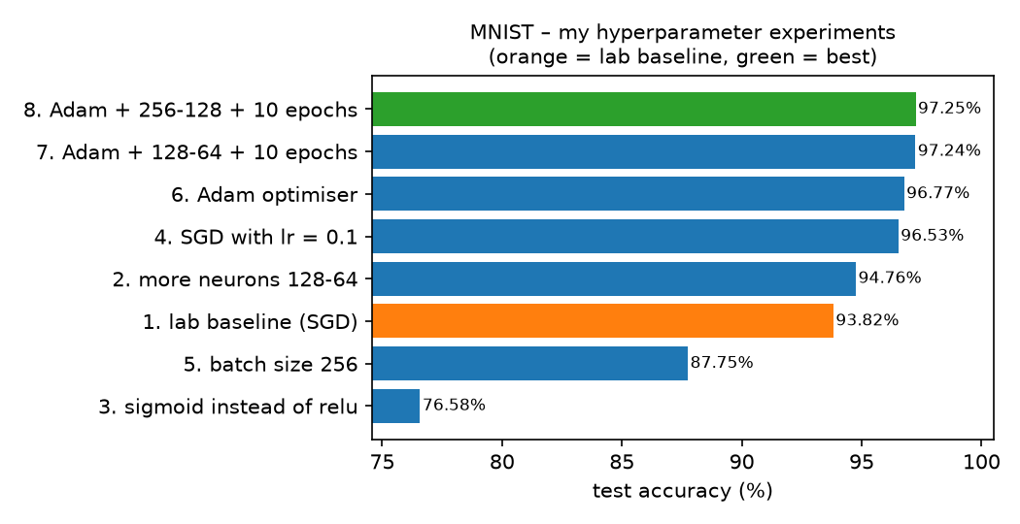
Figure 7.2 – test accuracy of my 8 hyperparameter experiments (orange = lab baseline, green = best)
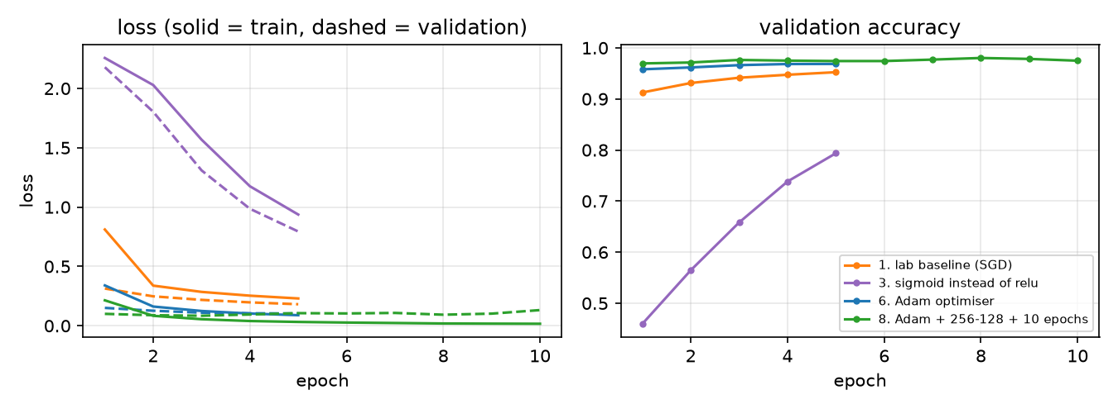
Figure 7.3 – learning curves – sigmoid learns slowly, Adam is fastest, the biggest model starts overfitting at the end
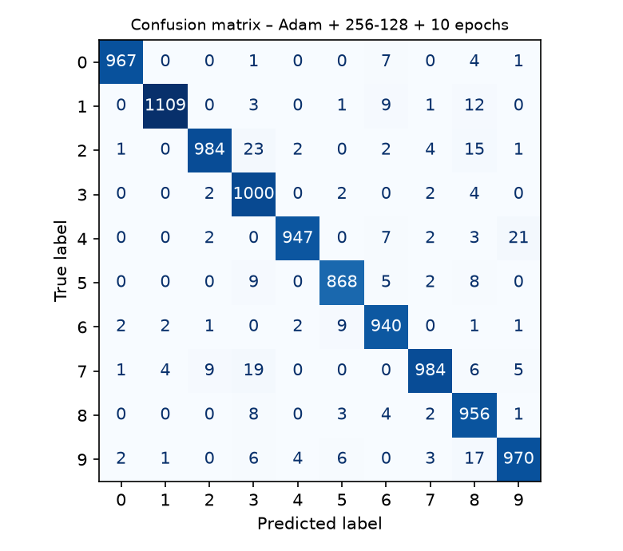
Figure 7.4 – confusion matrix of my best model (97.25% test accuracy)
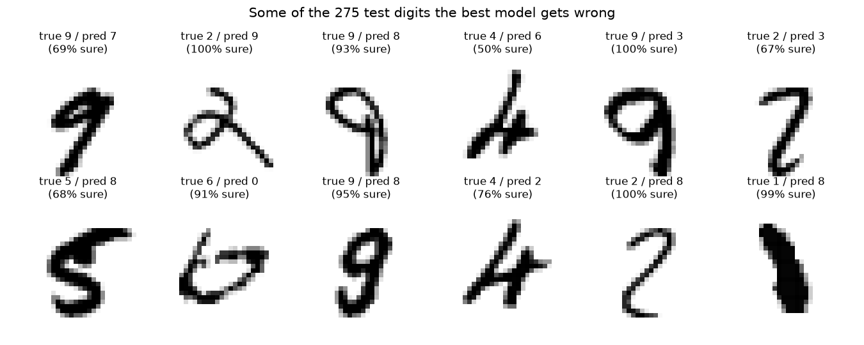
Figure 7.5 – some of the test digits my best model gets wrong
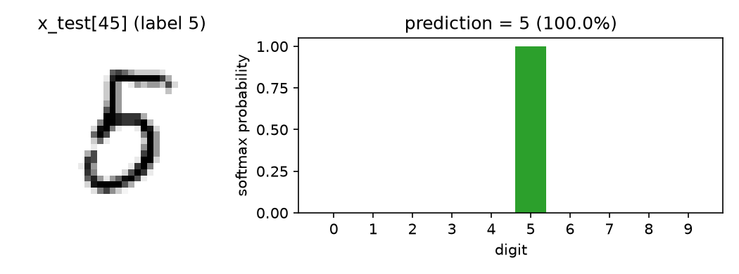
Figure 7.6 – the notebook's example digit x_test[45] and my best model's softmax output
[SCREENSHOT 7.1] pytorch.org – install command for my laptop
What to capture: the “Start Locally” selector on https://pytorch.org/get-started/locally/ with your OS, Package = Pip, Language = Python, Compute Platform = CPU (or your CUDA) and the generated “Run this Command” line.
Save as Lab 7/screenshots/7.1_pytorch_selector.png then run python _tools/insert_screenshots.py (or just paste the image here and delete this box).
Screenshot 7.1 – pytorch.org – install command for my laptop
[SCREENSHOT 7.2] Terminal – installed packages
What to capture: the end of pip install tensorflow + the PyTorch command, then pip list filtered for tensorflow / keras / torch (Windows: pip list | findstr /i "tensorflow keras torch").
Save as Lab 7/screenshots/7.2_pip_list.png then run python _tools/insert_screenshots.py (or just paste the image here and delete this box).
Screenshot 7.2 – Terminal – installed packages
[SCREENSHOT 7.3] Terminal – install check script
What to capture: full output of python screenshot_demo_install_check.py down to “Both frameworks work - ready for Lab 7!”.
Save as Lab 7/screenshots/7.3_install_check.png then run python _tools/insert_screenshots.py (or just paste the image here and delete this box).
Screenshot 7.3 – Terminal – install check script
[SCREENSHOT 7.4] neural_net.ipynb – model + training
What to capture: the “Create our Neural Network” cell, all 13 lines (line 2 = my seed, lines 6–7 = the original InputLayer line commented out + my fix InputLayer(shape=(28*28,))) and the model.compile/model.fit cell with all 5 epochs.
Save as Lab 7/screenshots/7.4_nn_model_training.png then run python _tools/insert_screenshots.py (or just paste the image here and delete this box).
Screenshot 7.4 – neural_net.ipynb – model + training
[SCREENSHOT 7.5] neural_net.ipynb – test accuracy + prediction
What to capture: the evaluate cells (Test accuracy ≈ 0.938) and the prediction section: the x_test[45] image and “Predicted label is: 5”.
Save as Lab 7/screenshots/7.5_nn_test_prediction.png then run python _tools/insert_screenshots.py (or just paste the image here and delete this box).
Screenshot 7.5 – neural_net.ipynb – test accuracy + prediction
[SCREENSHOT 7.6] nn_experiments.ipynb – my experiment results
What to capture: the output of the experiments cell (the 8 lines + the results table).
Save as Lab 7/screenshots/7.6_experiments_table.png then run python _tools/insert_screenshots.py (or just paste the image here and delete this box).
Screenshot 7.6 – nn_experiments.ipynb – my experiment results
[SCREENSHOT 7.7] nn_pytorch.ipynb – PyTorch training
What to capture: the training cell and its output (5 epochs, test accuracy ≈ 0.976).
Save as Lab 7/screenshots/7.7_pytorch_training.png then run python _tools/insert_screenshots.py (or just paste the image here and delete this box).
Screenshot 7.7 – nn_pytorch.ipynb – PyTorch training

